**ST. XAVIER’S COLLEGE**

**Maitighar, Kathmandu**



DATABASE MANAGEMENT SYSTEM

theory Assignment #4

**Submitted by:**

Sushant Gautam

013BSCCSIT043

**Submitted to:**

Er. Sanjay Kr. Yadav

Lecturer, St. Xavier’s college

Department of Computer Science

**Date of Submission:**

August 10, 2015

**E-R Diagram with case study:**

A small accounting firm wants a simple HR application that will help it to keep track of its employees, their positions, allowances, salary scales, and which company vehicles their employees drive.

The application must keep track of all the positions at the firm, the employees filling these positions, the allowances for these positions, the salary scales for these positions, and the company vehicles assigned to these positions.

Below is the Simplified Entity-Relationship diagram that is output from Step 3 of the six step database design process as described in [Six-Step Relational Database Design](http://www.fidelcaptain.com/publications/books/sixstep.html):

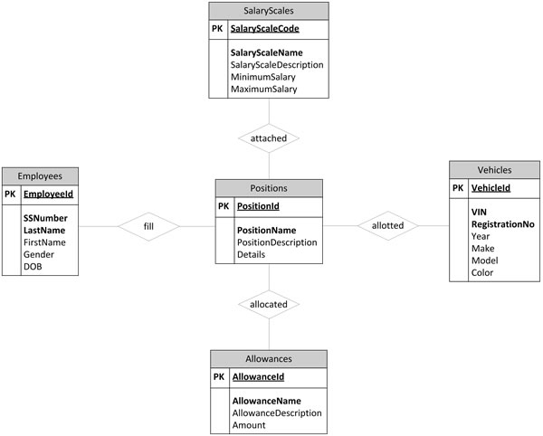

**Database design:**

Database design is the process of producing a detailed data model of a database. This logical data model contains all the needed logical and physical design choices and physical storage parameters needed to generate a design in a data definition language, which can then be used to create a database.

**Conceptual Design**

Once all the requirements have been collected and analyzed, the next step is to create a conceptual schema for the database, using a high level conceptual data model. This phase is called conceptual design.  
  
 The result of this phase is an Entity-Relationship (ER) diagram or UML class diagram. It is a high-level data model of the specific application area. It describes how different entities (objects, items) are related to each other. It also describes what attributes (features) each entity has. It includes the definitions of all the concepts (entities, attributes) of the application area.  
  
 During or after the conceptual schema design, the basic data model operations can be used to specify the high-level user operations identified during the functional analysis. This also serves to confirm that the conceptual schema meets all the indentified functional requirements.

**Logical Database Design:**

Once all the requirements have been collected and analyzed, the next step is to create a conceptual schema for the database, using a high level conceptual data model. This phase is called conceptual design.  
  
The result of this phase is an Entity-Relationship (ER) diagram or UML class diagram. It is a high-level data model of the specific application area. It describes how different entities (objects, items) are related to each other. It also describes what attributes (features) each entity has. It includes the definitions of all the concepts (entities, attributes) of the application area.  
  
During or after the conceptual schema design, the basic data model operations can be used to specify the high-level user operations identified during the functional analysis. This also serves to confirm that the conceptual schema meets all the indentified functional requirements.

**Physical Design**

The goal of the last phase of database design, physical design, is to implement the database. At this phase one must know which database management system (DBMS) is used. For example, different DBMS's have different names for data types and have different data types.  
  
The SQL clauses to create the database are written. The indexes, the integrity constraints (rules) and the users' access rights are defined.

Finally the data to test the database is added in.  
  
In parallel with these activities, application programs are designed. The implementation of the programs can start when the database is created and data has been added in. Source: Elmasri, Navathe. 2004. Fundamentals of Database Systems. Addison-Wesley. Chapter 3. Data Modelling Using the Entity-Relationship Model.